CAPSTONE PROJECT  
Assignment 4(LSP): Network File Sharing Server & Client

**Objective:** Develop a networked file sharing application with a server and client architecture, enabling file transfers over sockets.

This project implements a basic client-server file transfer system using TCP sockets in C. Users can upload and download files between client and server machines over a local network. The project demonstrates fundamental network programming concepts, socket communication, and file I/O, and serves as a foundational exercise for building secure distributed systems.

**Day 1:** Setup server-client socket communication.

# Server Code:

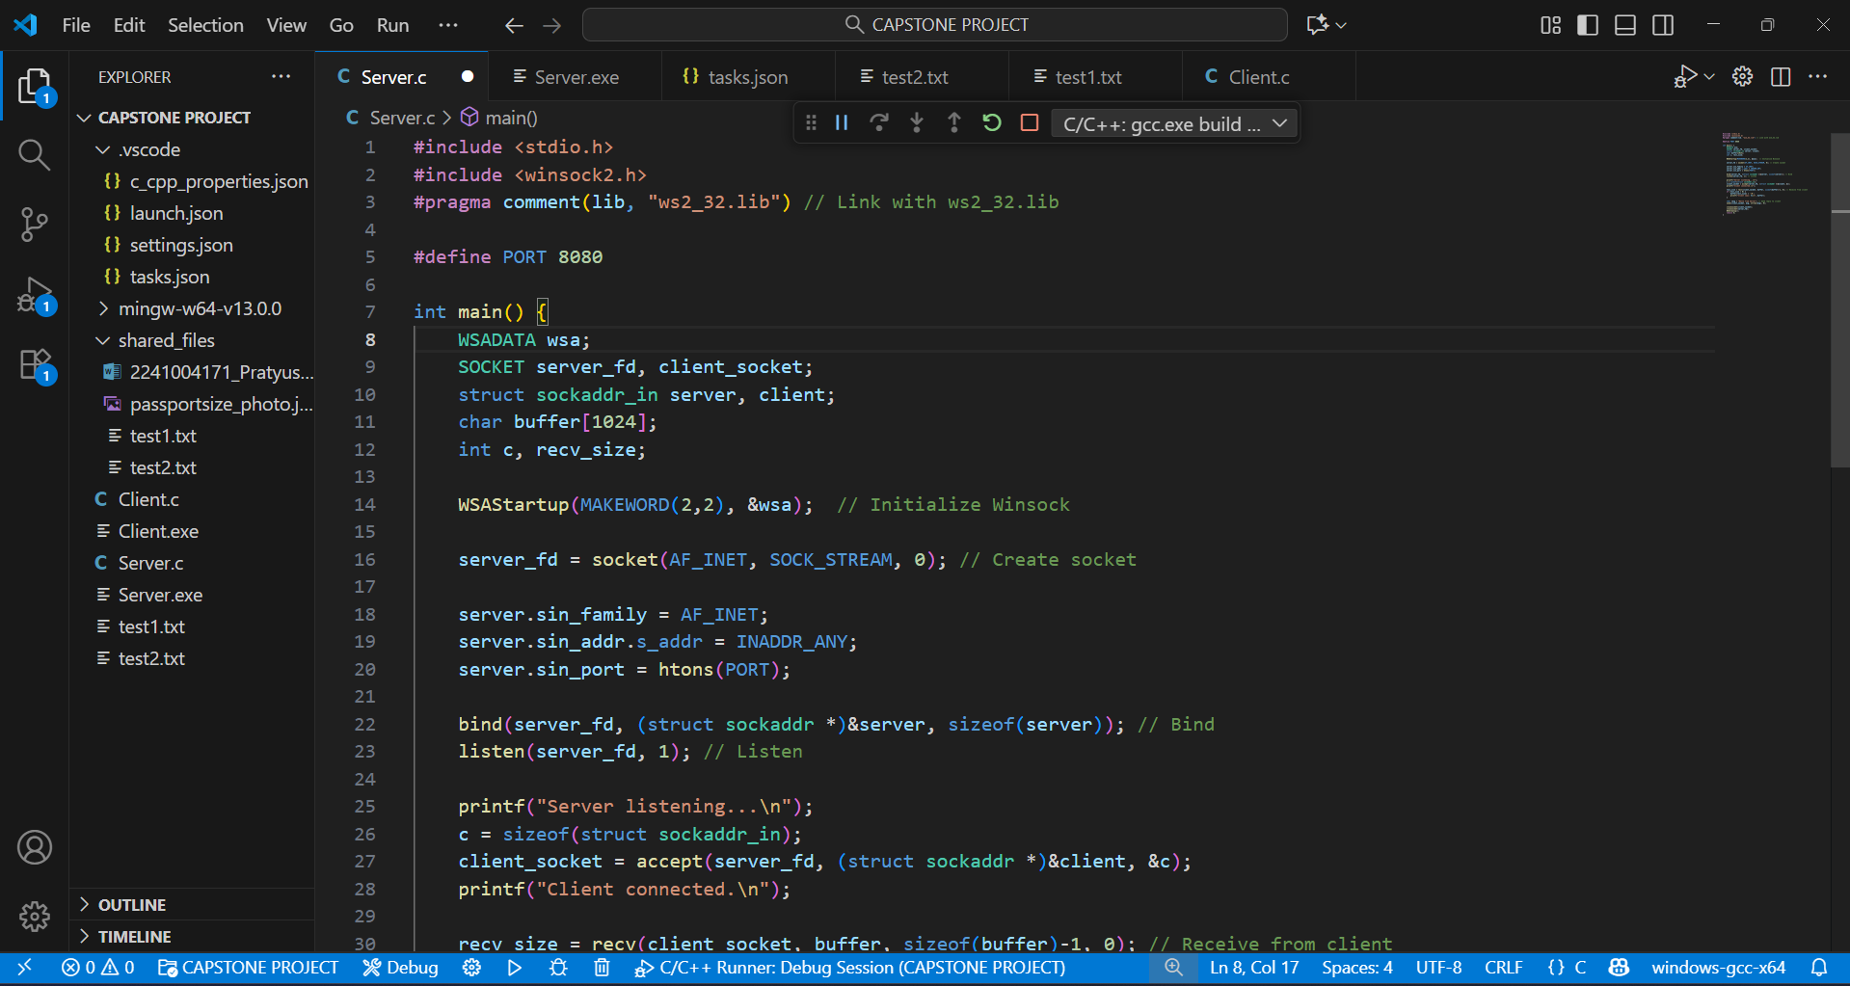

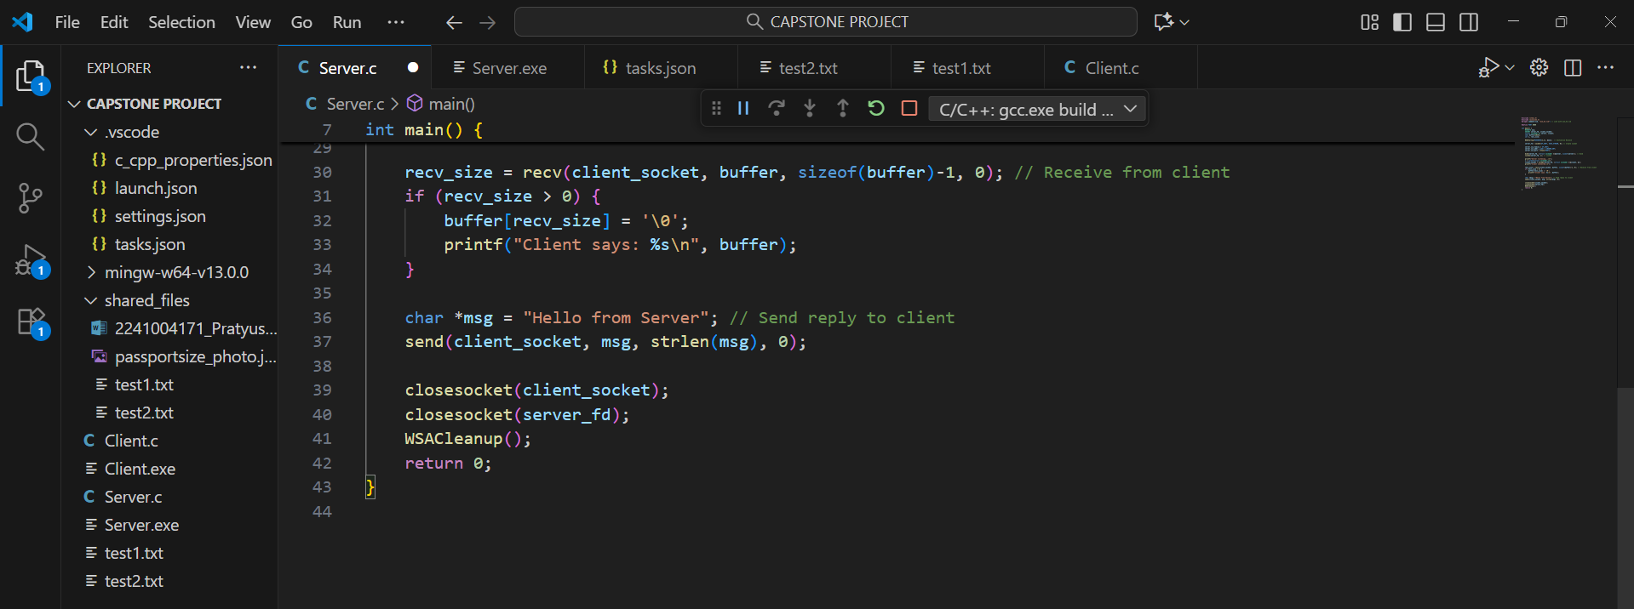

# Client code:

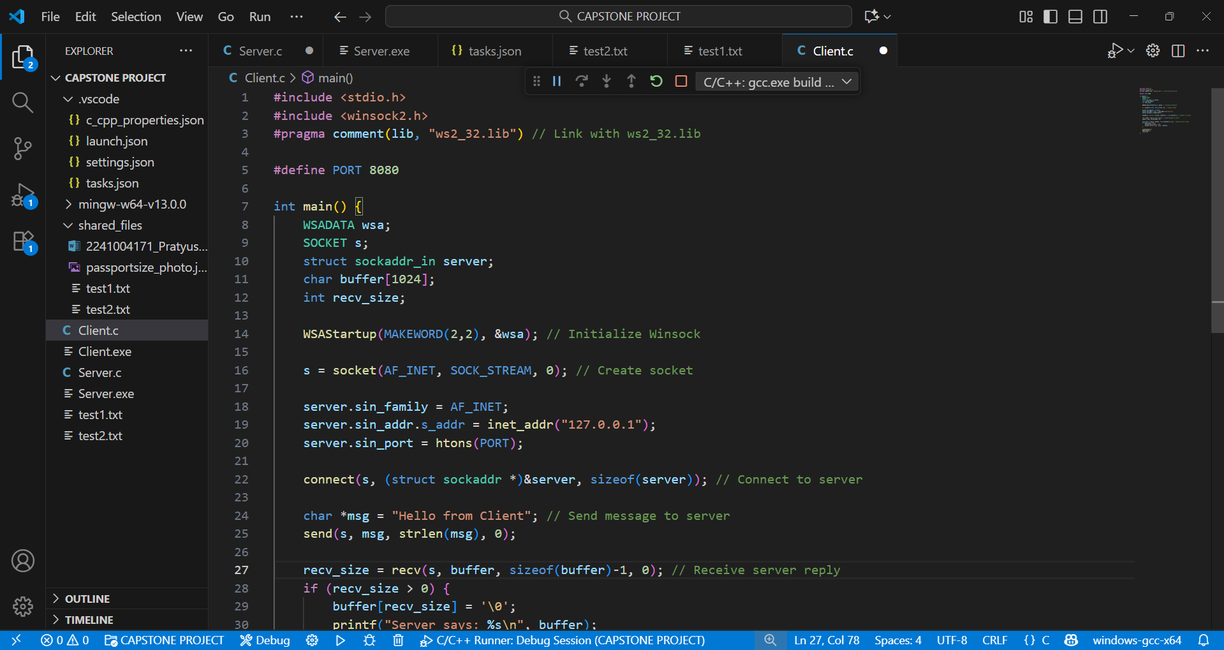

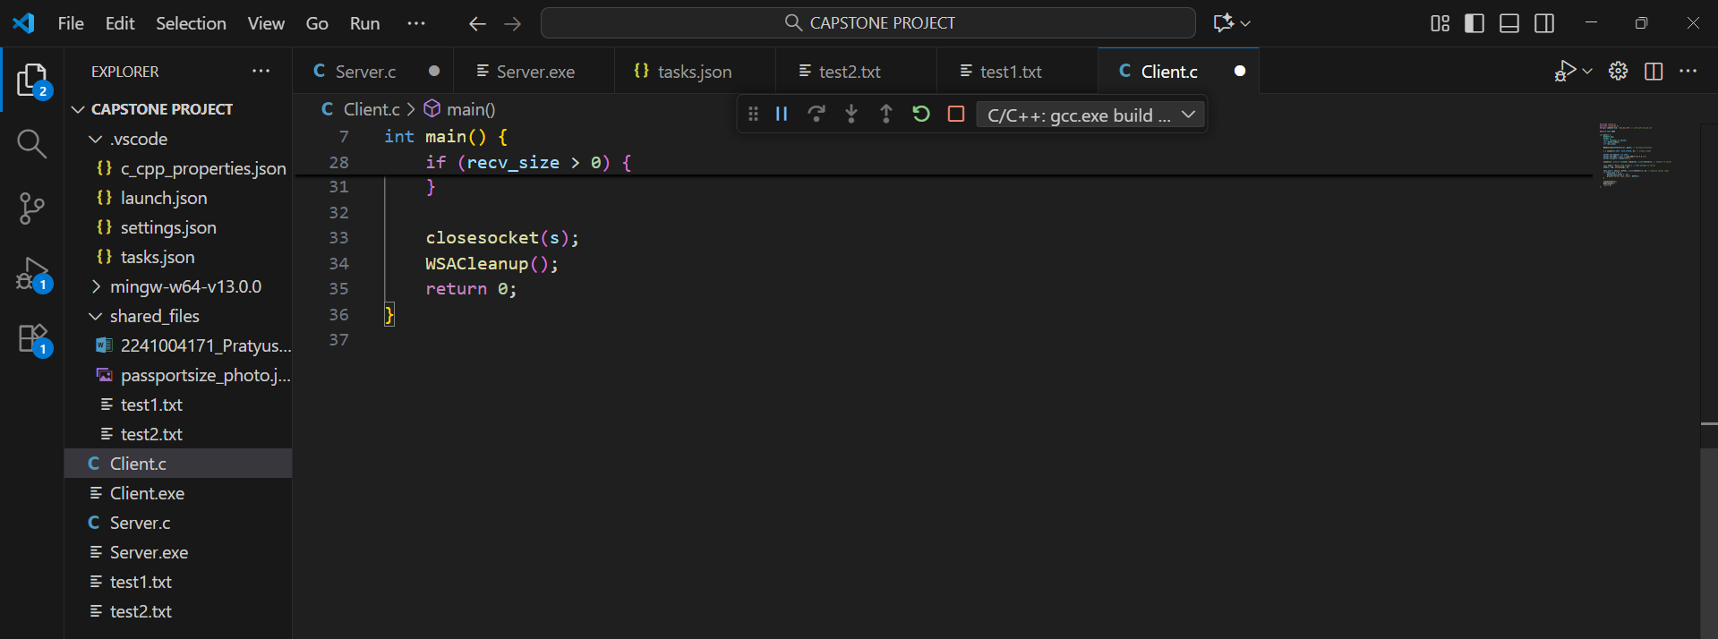

# Terminal Output:

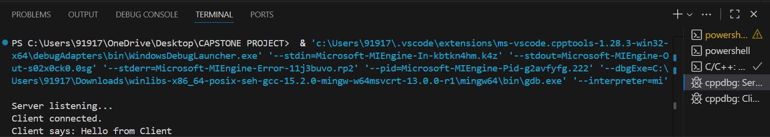

**Day 2**: Implement file listing and selection feature on the client side.

* These are the files made in the folder i.e (shared_files) which is in the main folder CAPSTONE PROJECT.

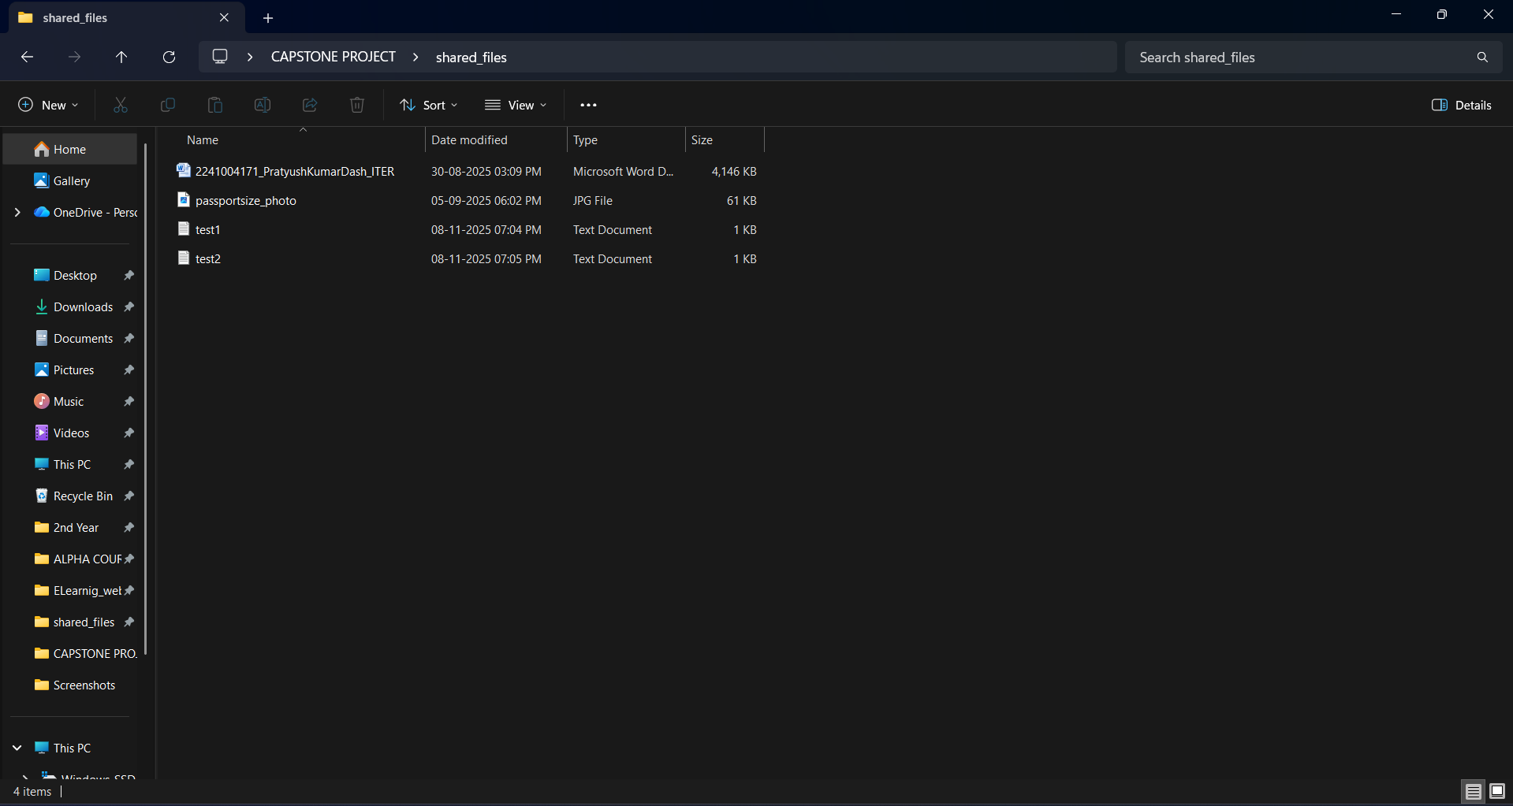

# Server code:

We need to add this part of code to the previous one i.e Directory listing code

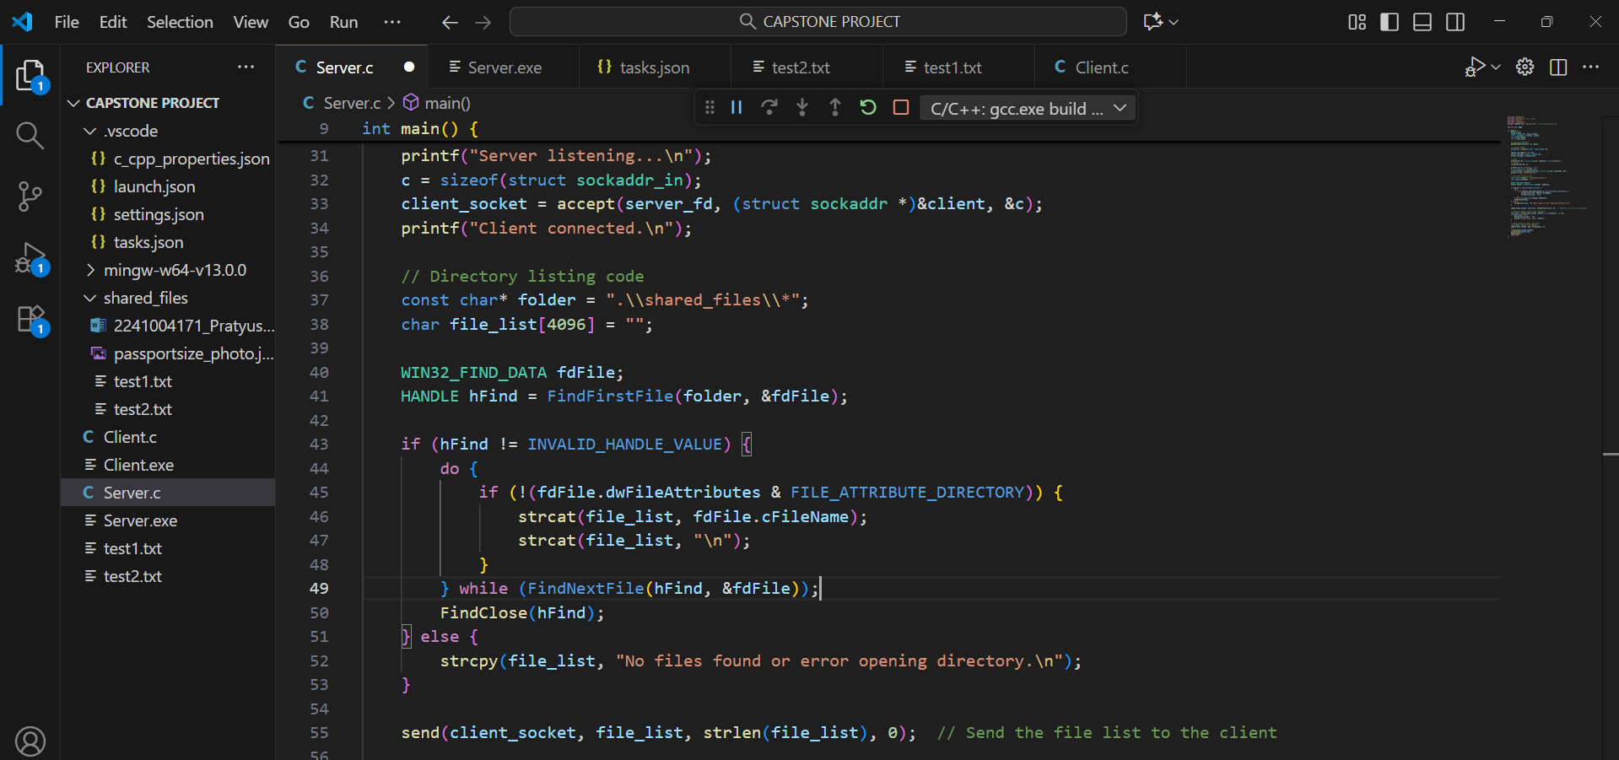

# Client code:

Add the code // Recieve the file list from server to the previous code.

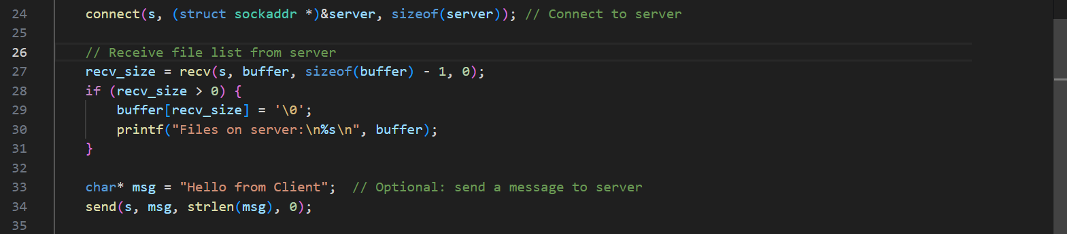

# Terminal Output:

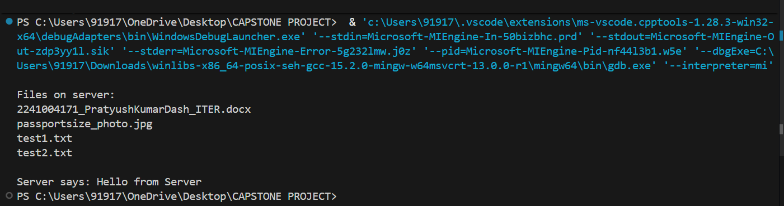

**Day 3**: Enable file transfer from server to client.

# Server code:

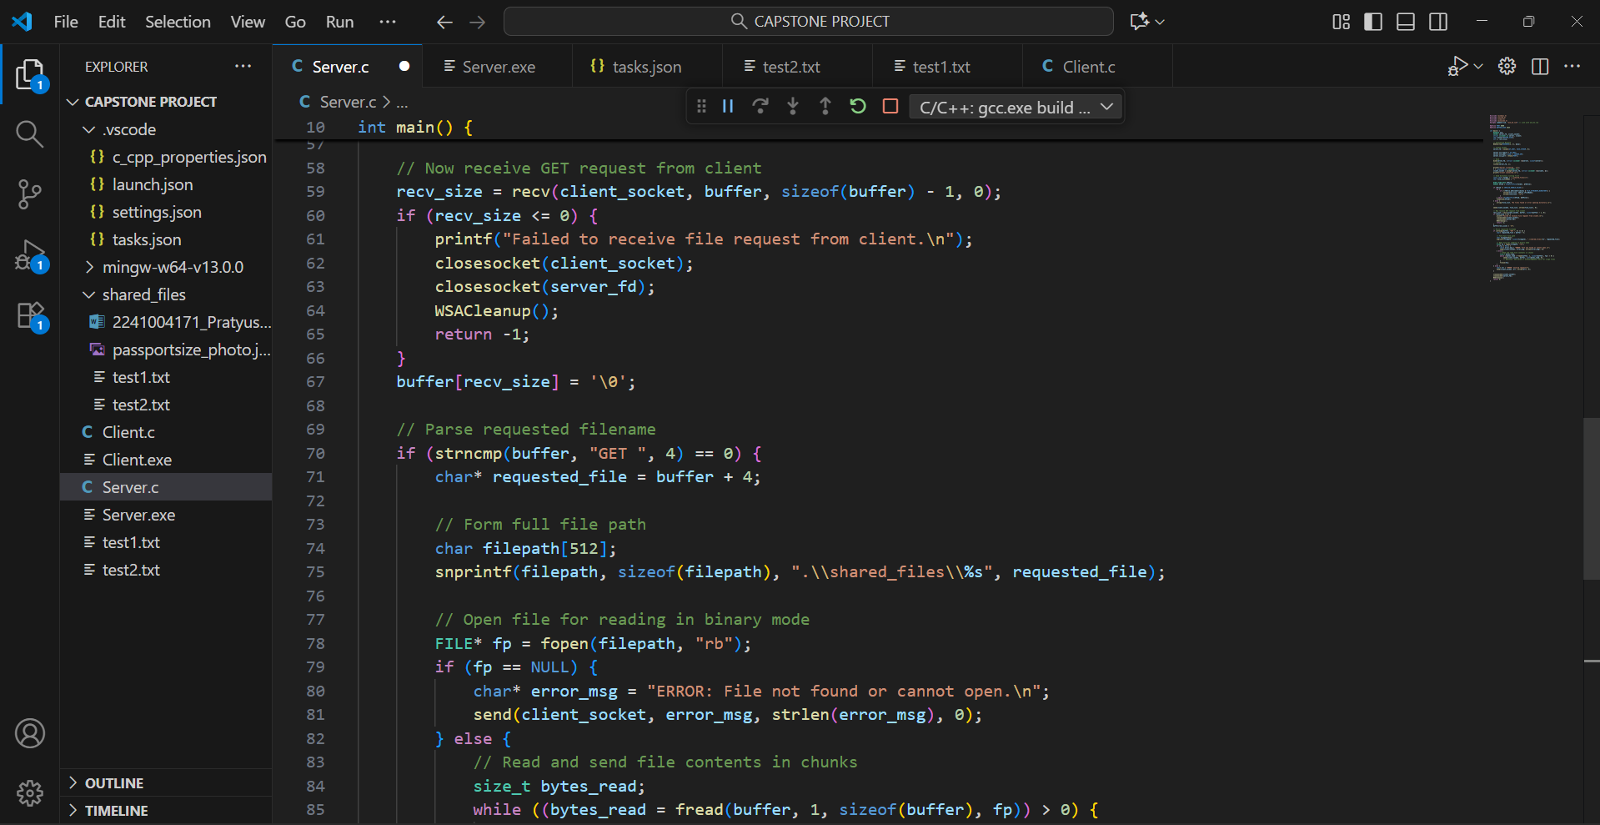

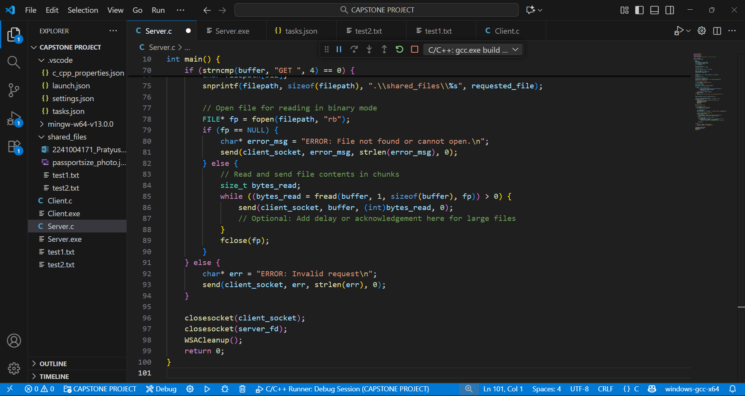

# Client code:

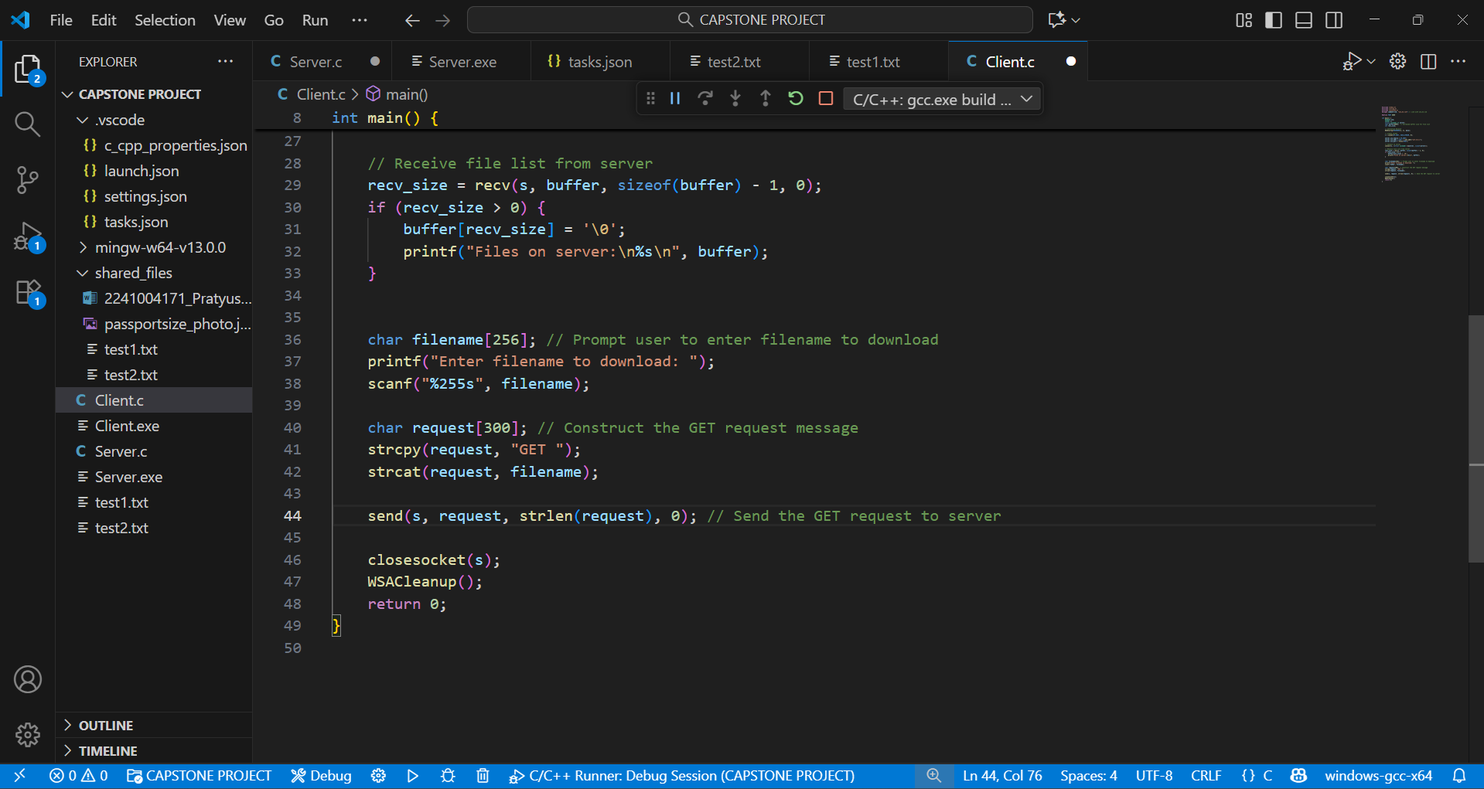

# Terminal Output:

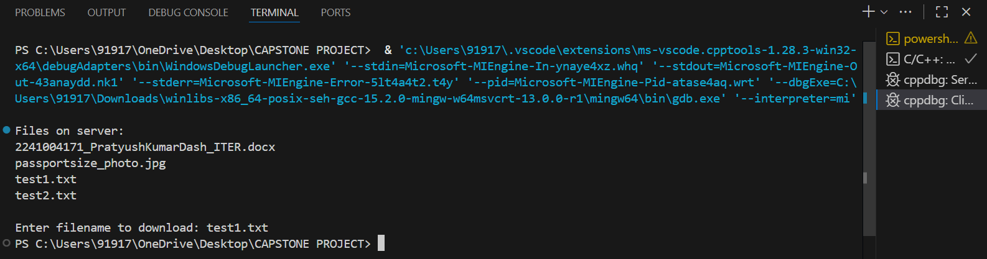

So here the files are downloaded in the main folder i.e CAPSTONE PROJECT

Before there were inside the shared files but now they are in the main folder.

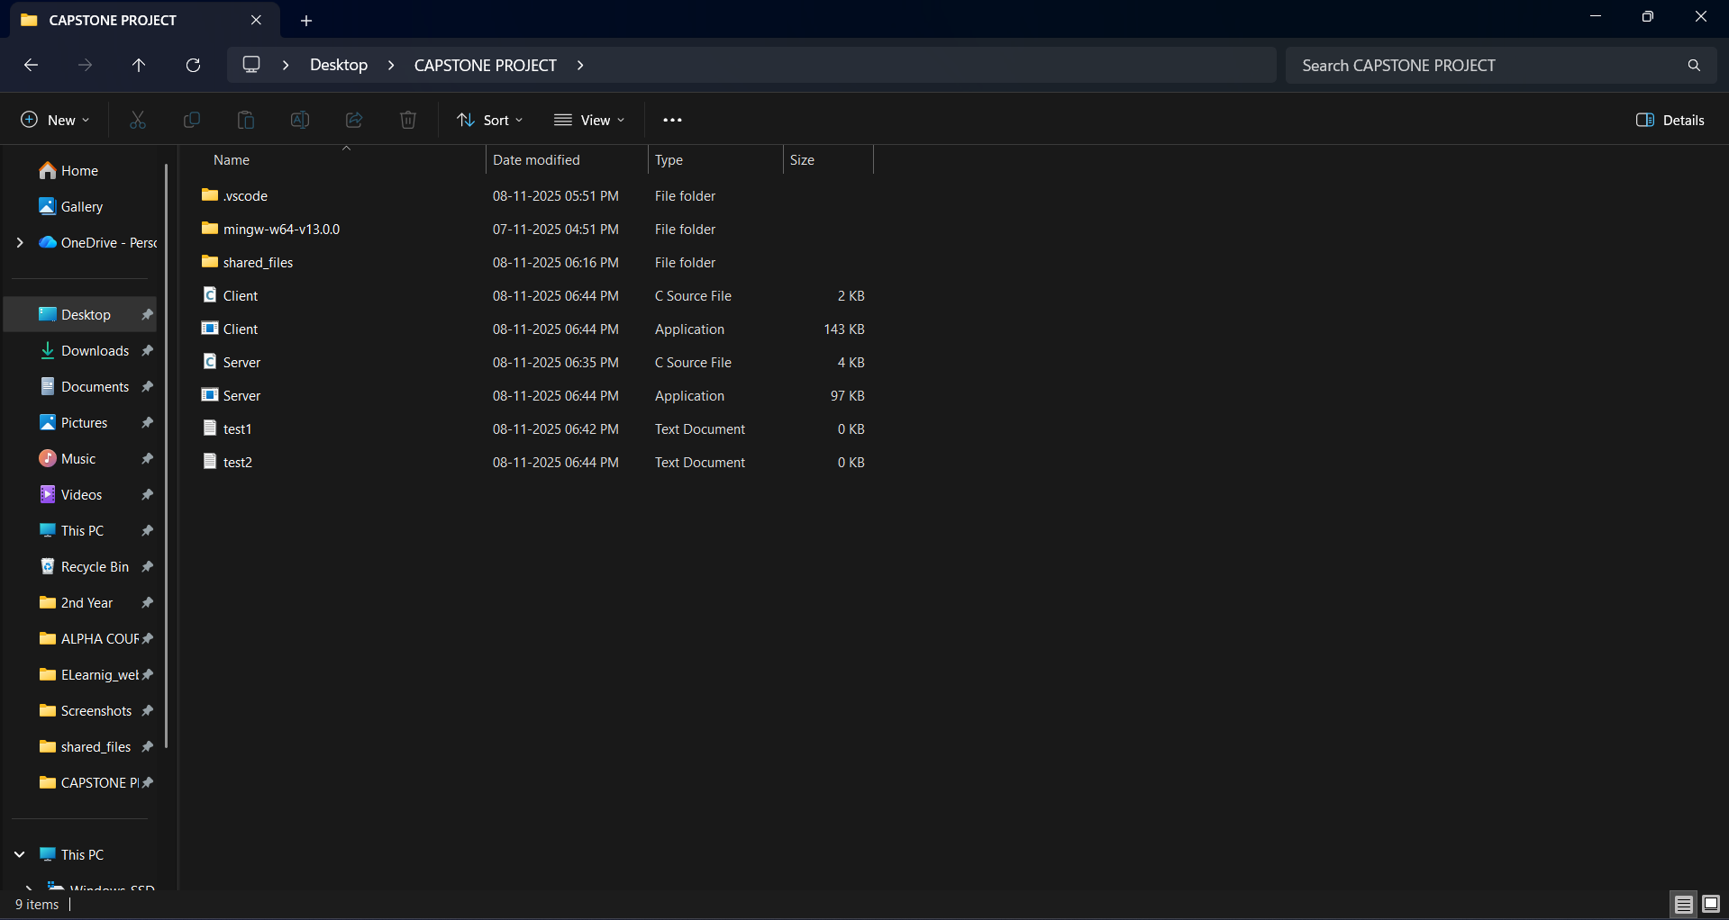

**Day 4:** Add file upload functionality from client to server.

# Server code:

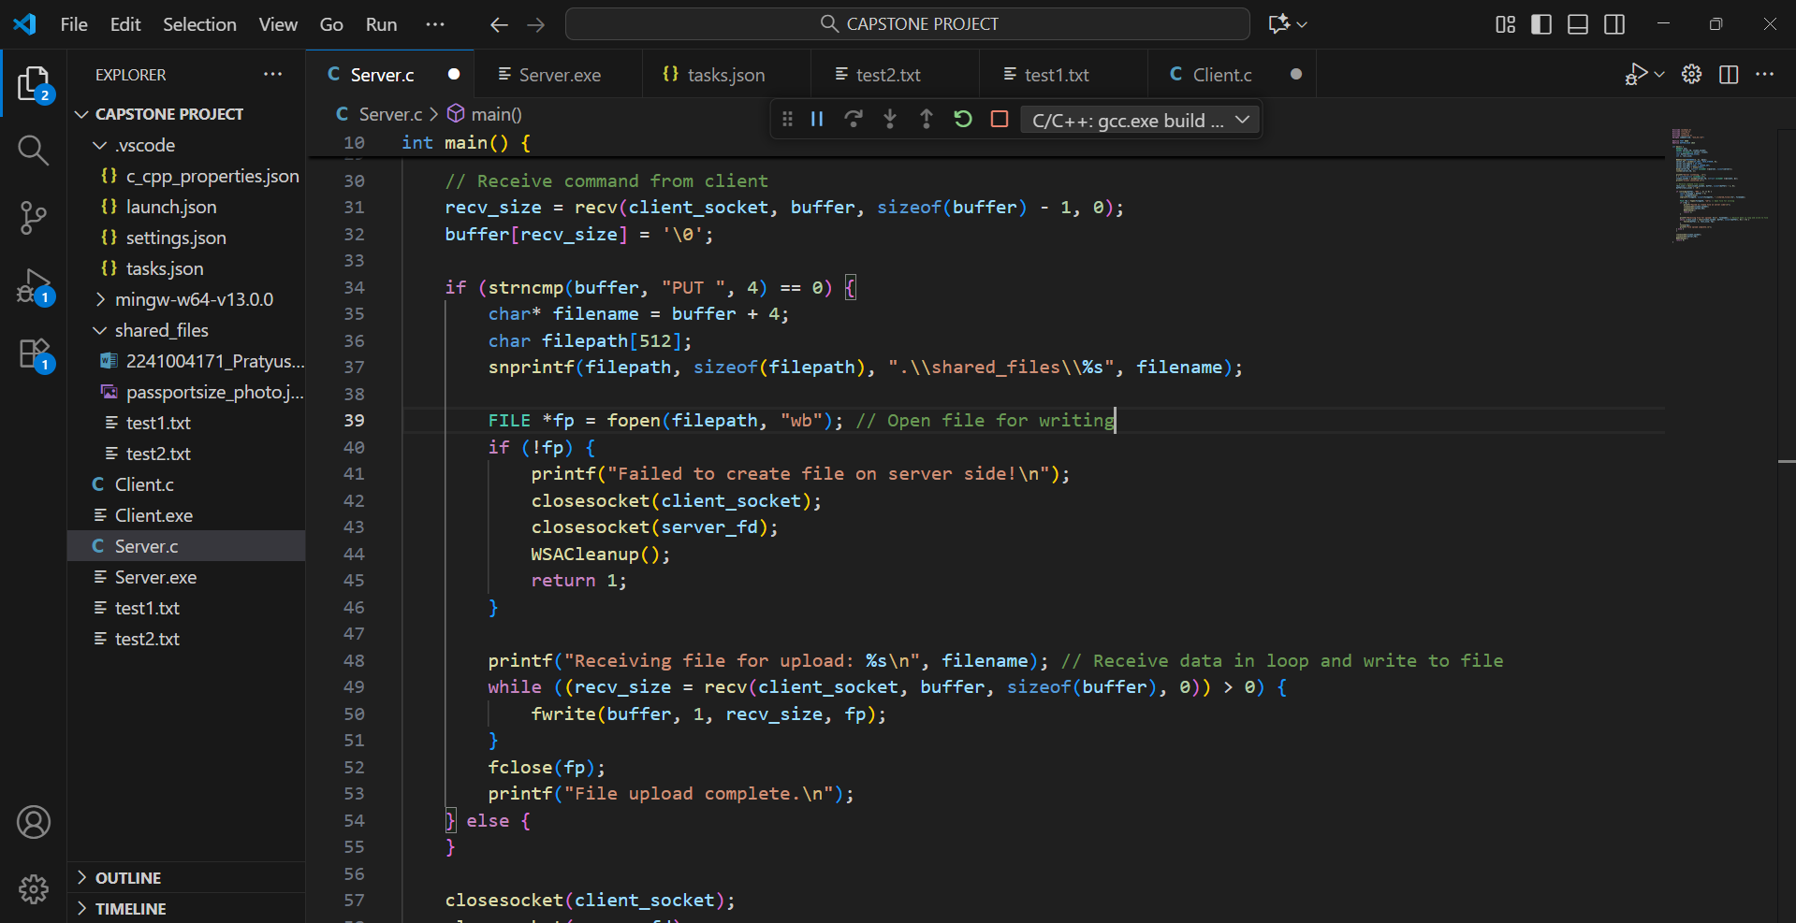

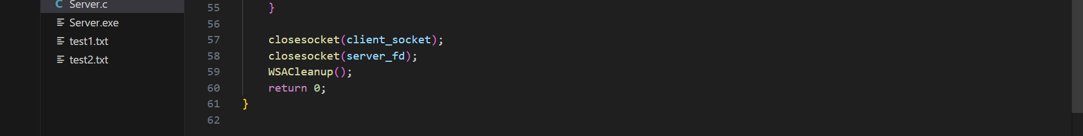

# Client code:

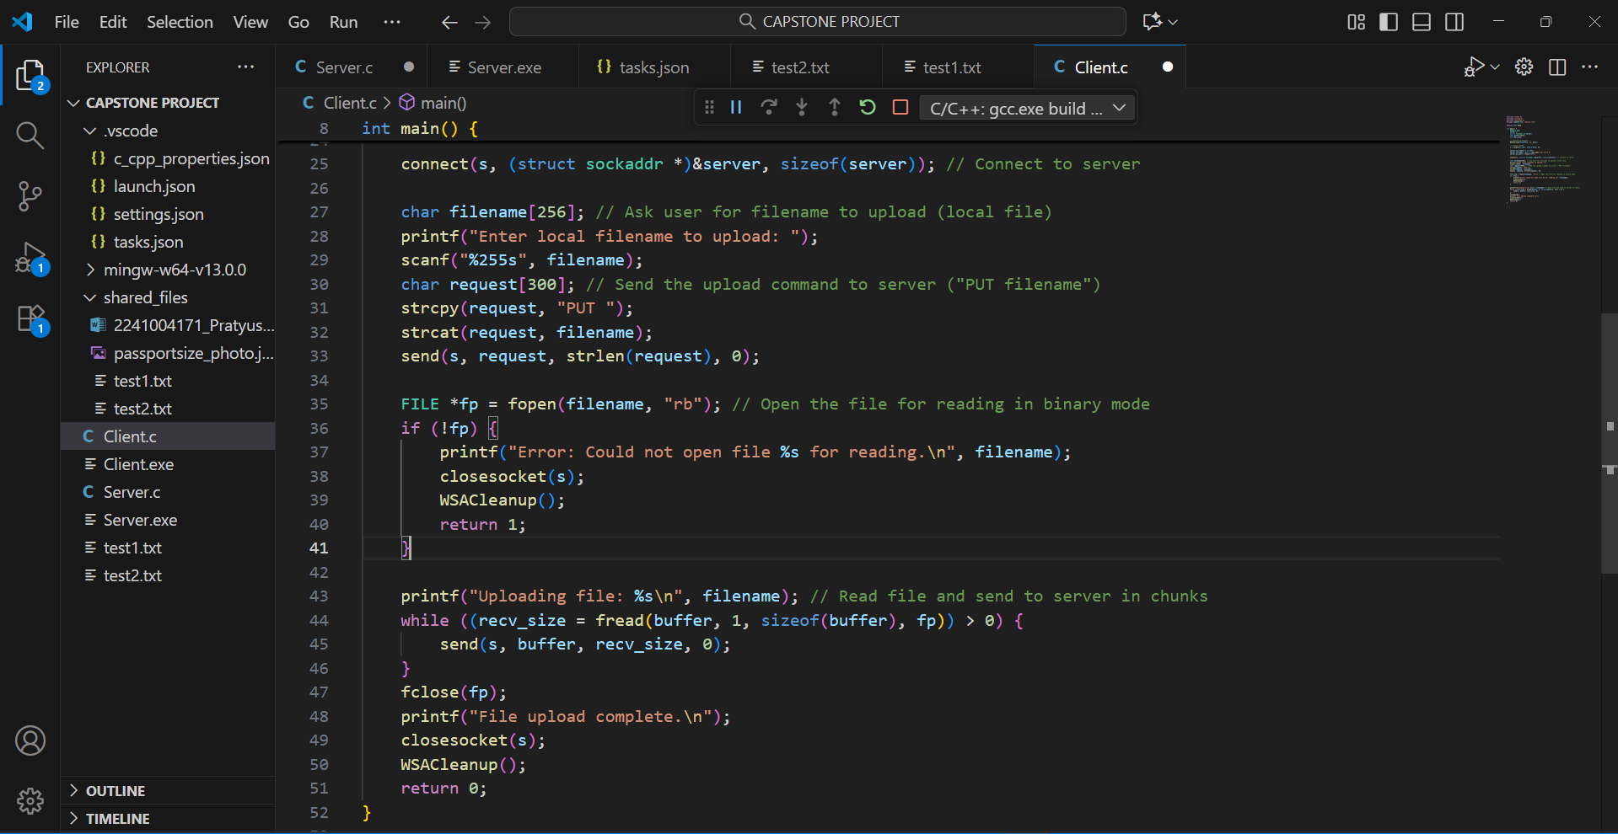

# Terminal Output:

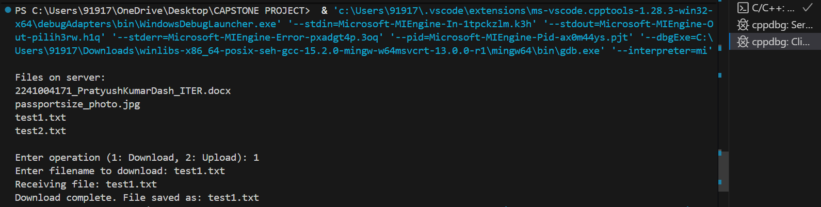

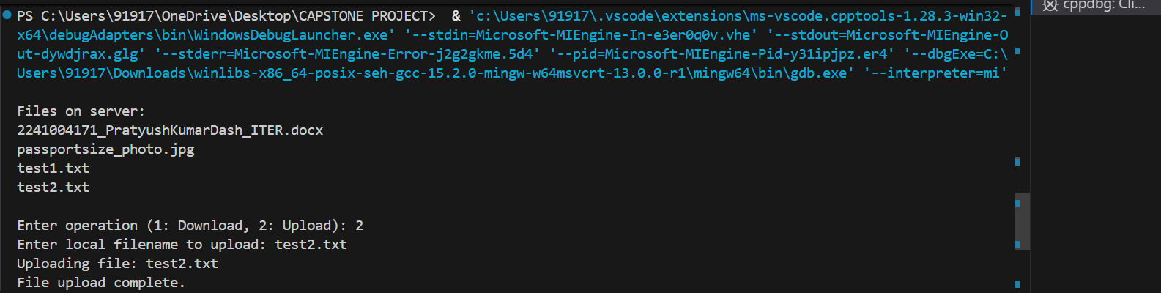

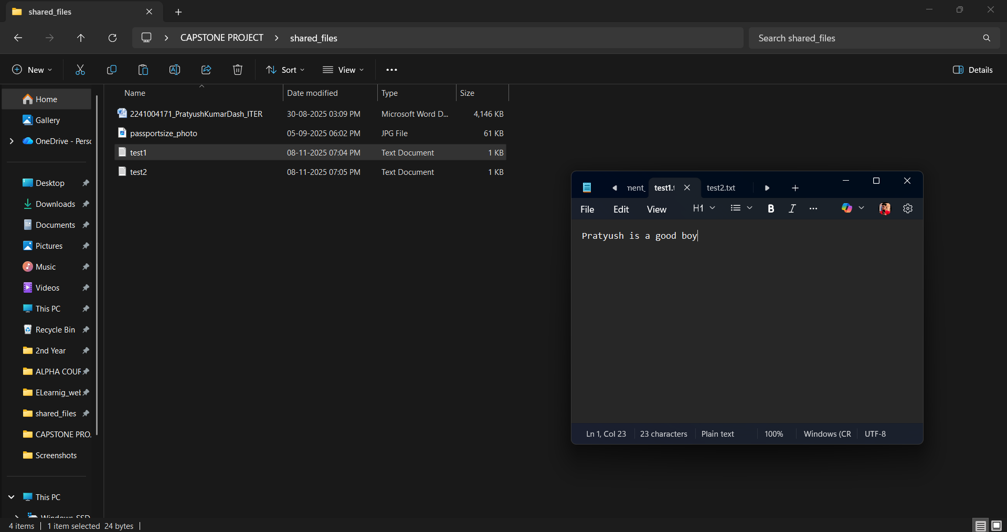

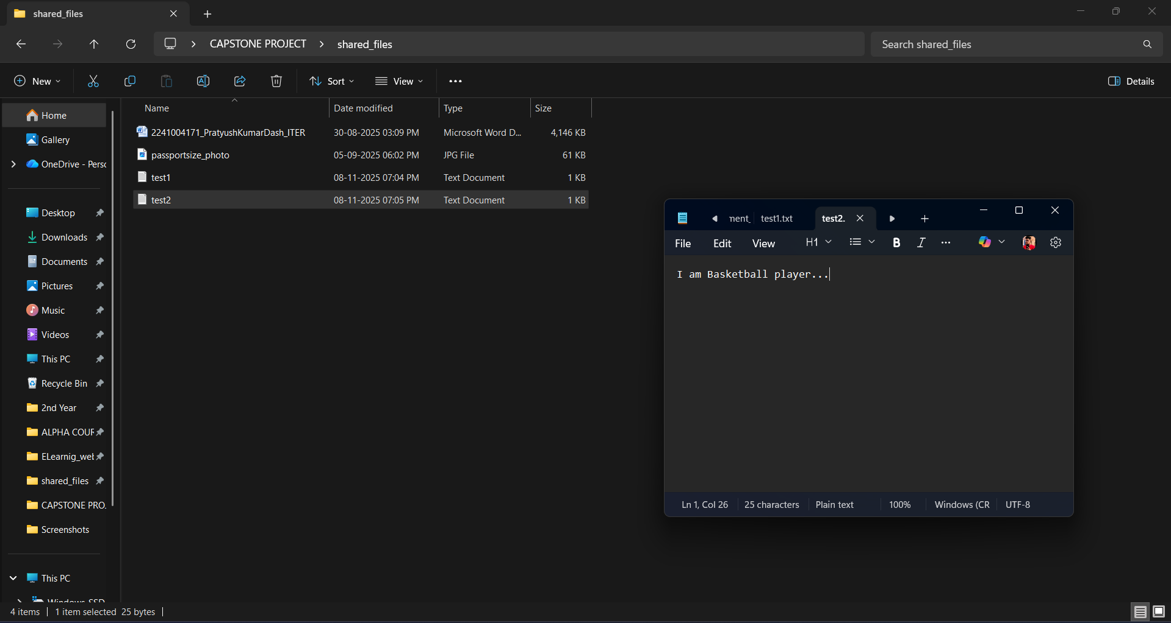

Same thing will be downloaded and uploaded in the main folder i.e CAPSTONE PROJECT in their respective file **test1.txt** ,**test2.txt**

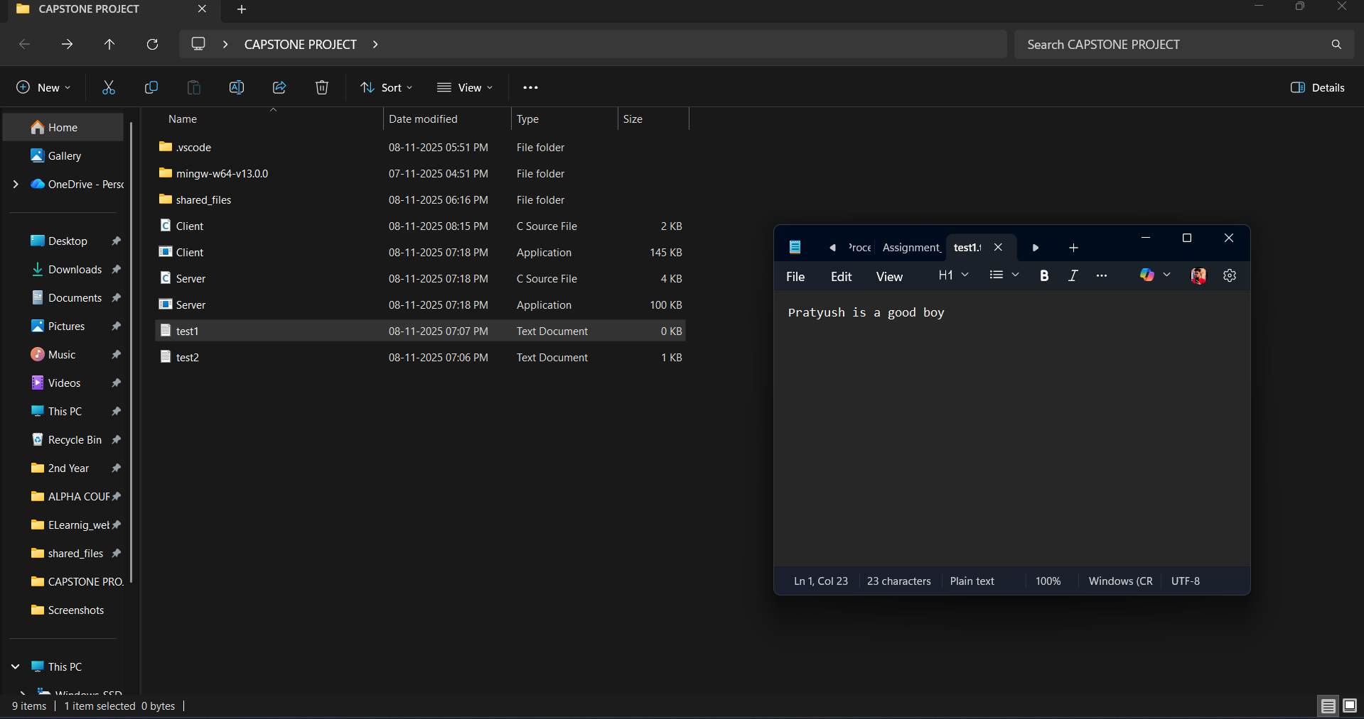

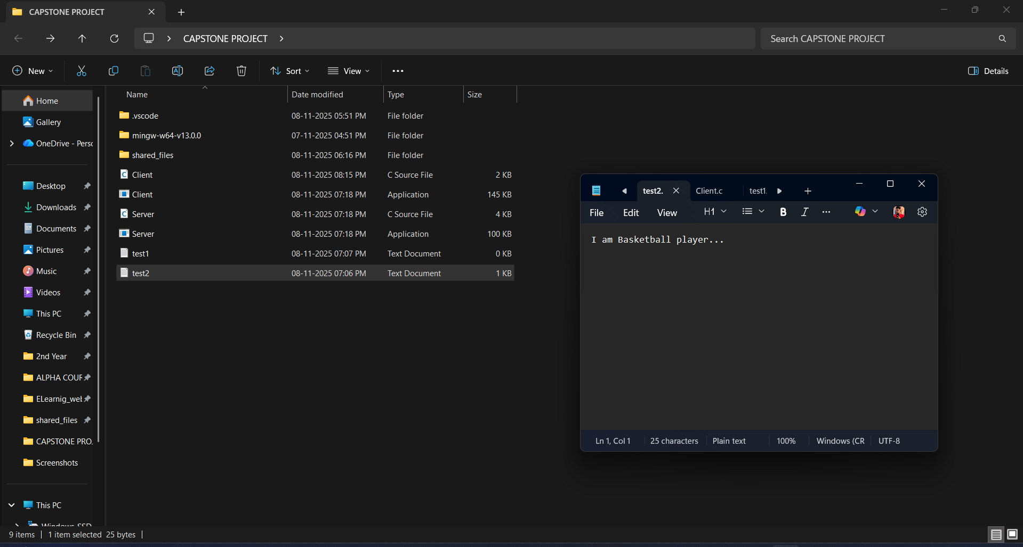

**Day 5**: Implement security features like authentication and encryption

So the complete code for Server and client are as follows :-

# Server code:

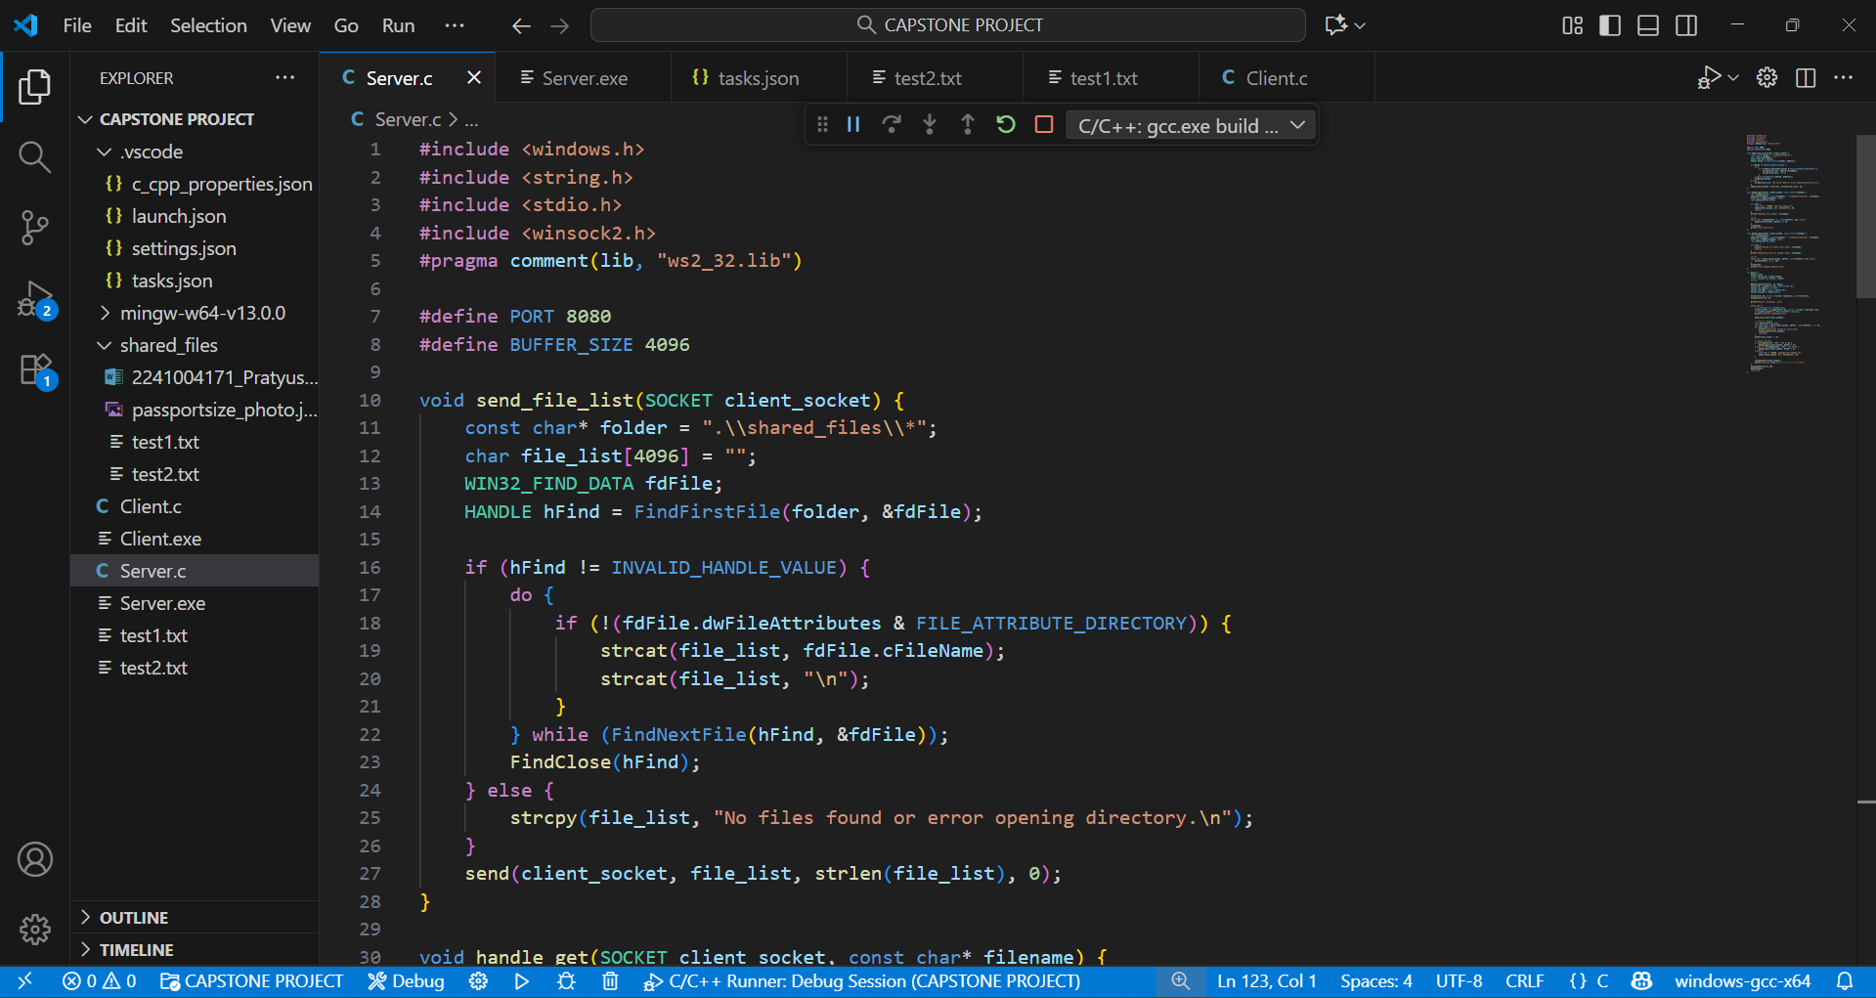

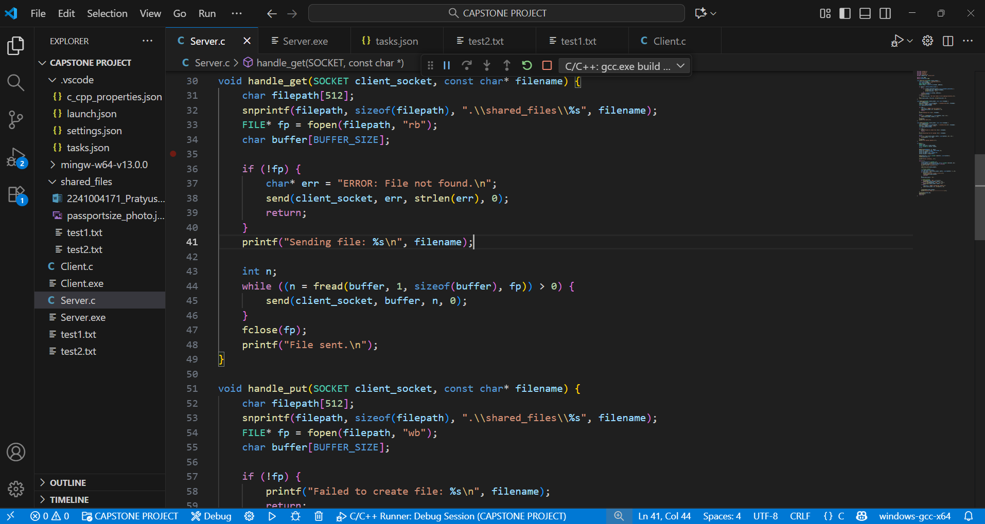

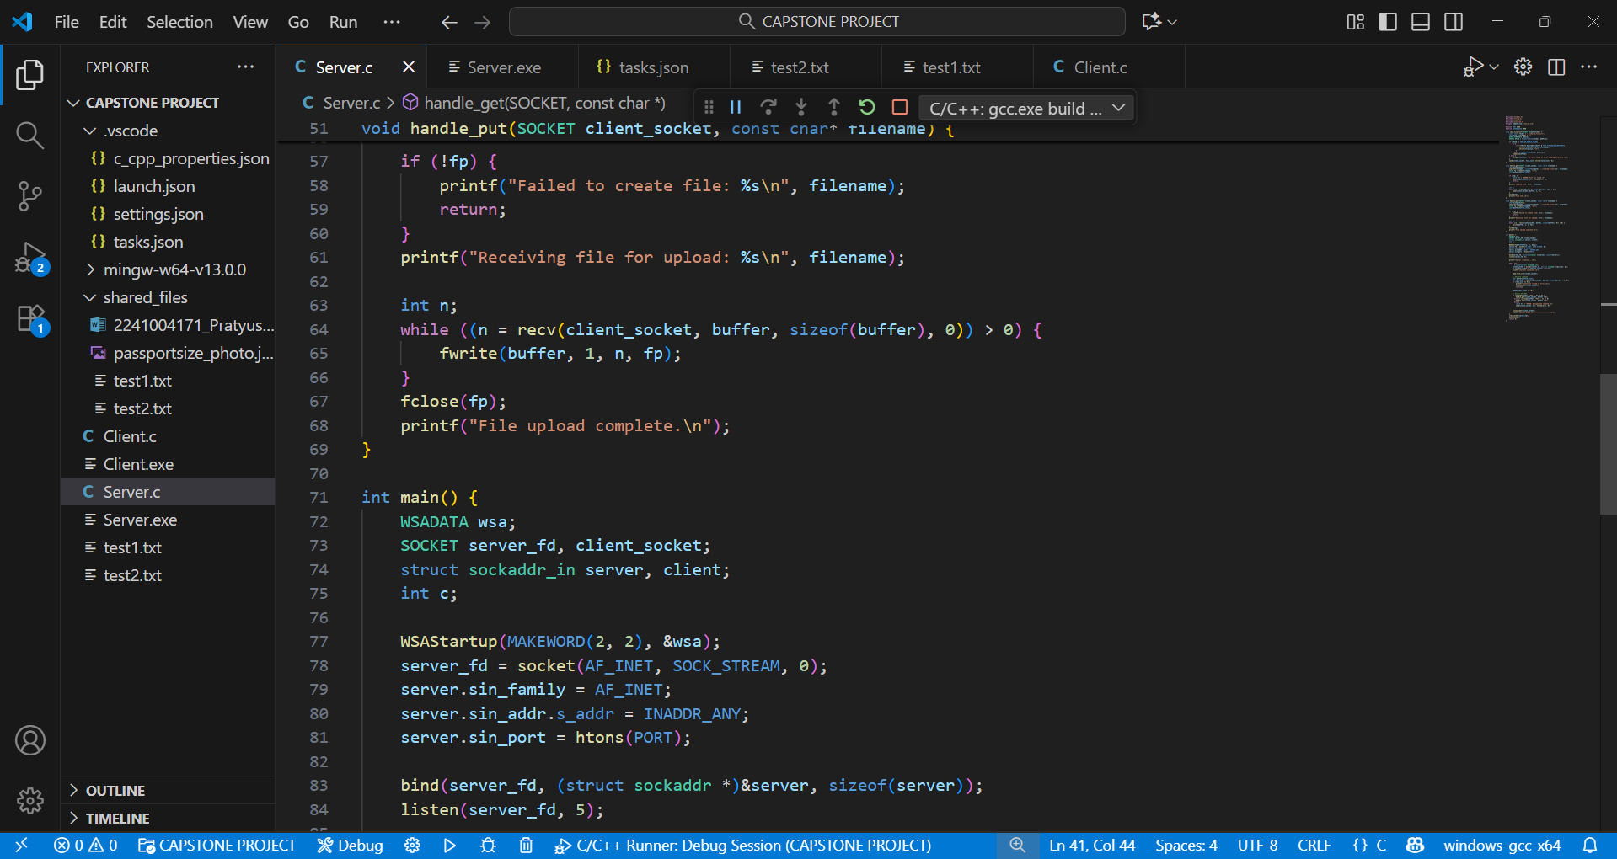

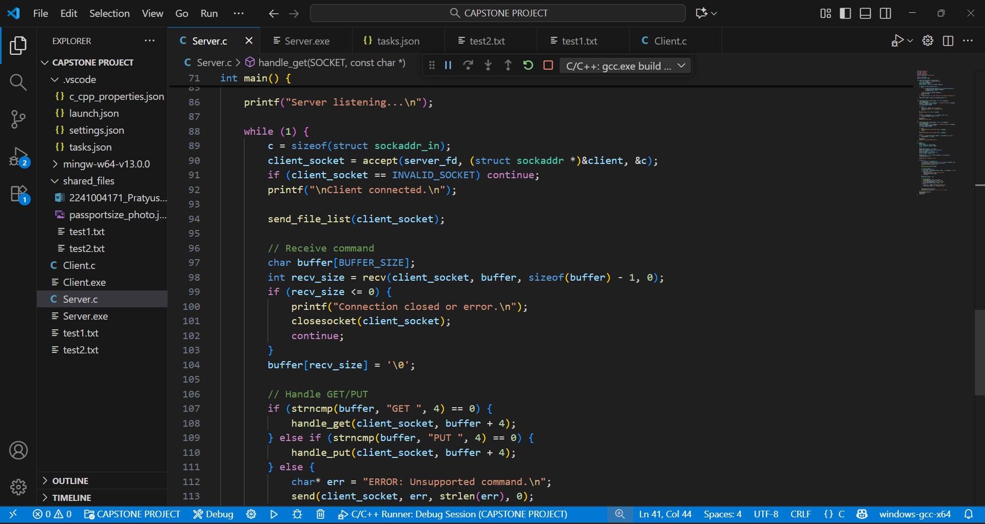

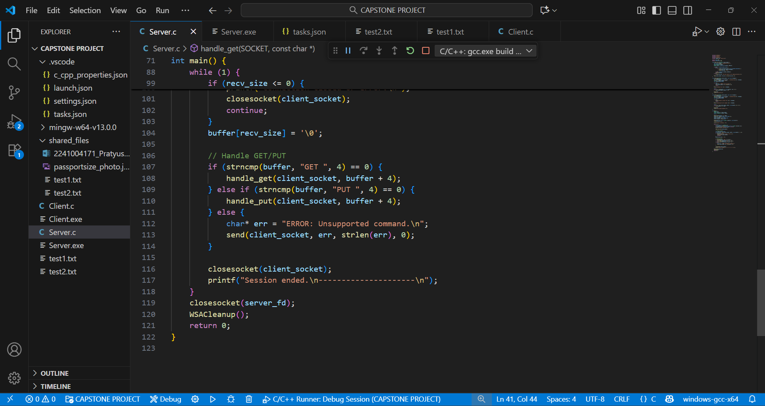

# Client code:

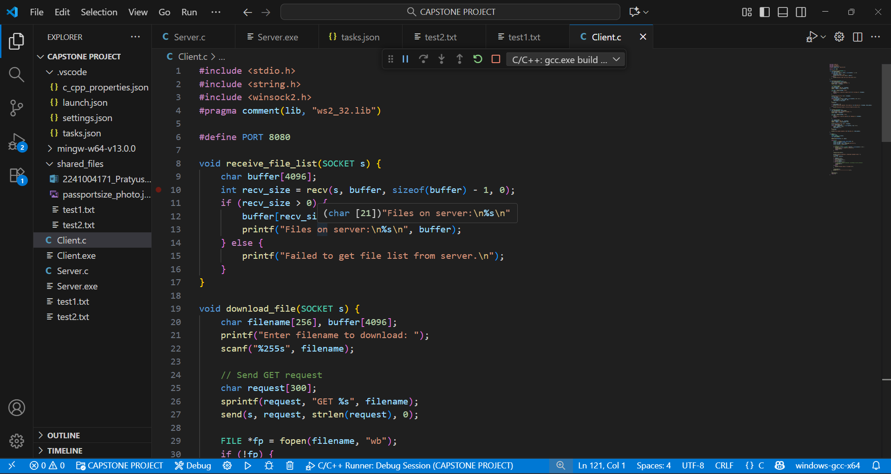

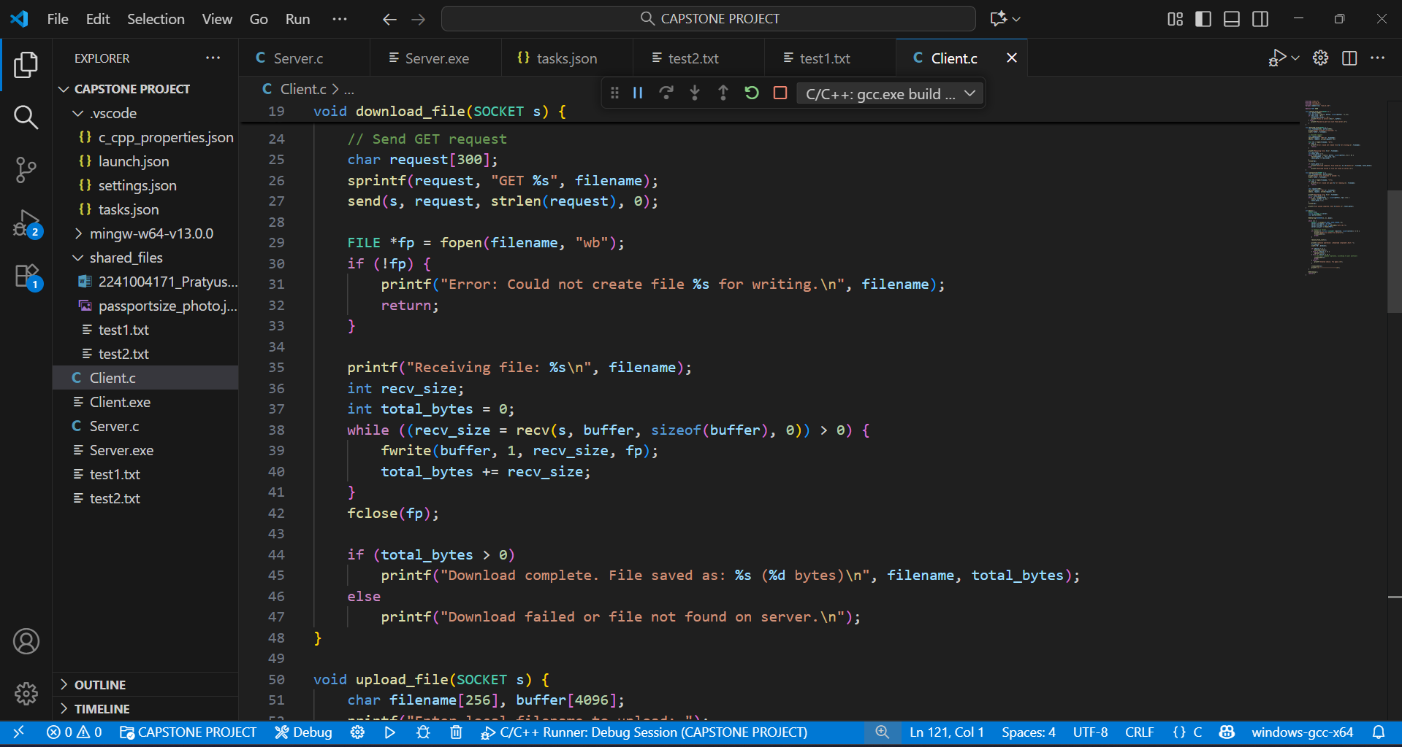

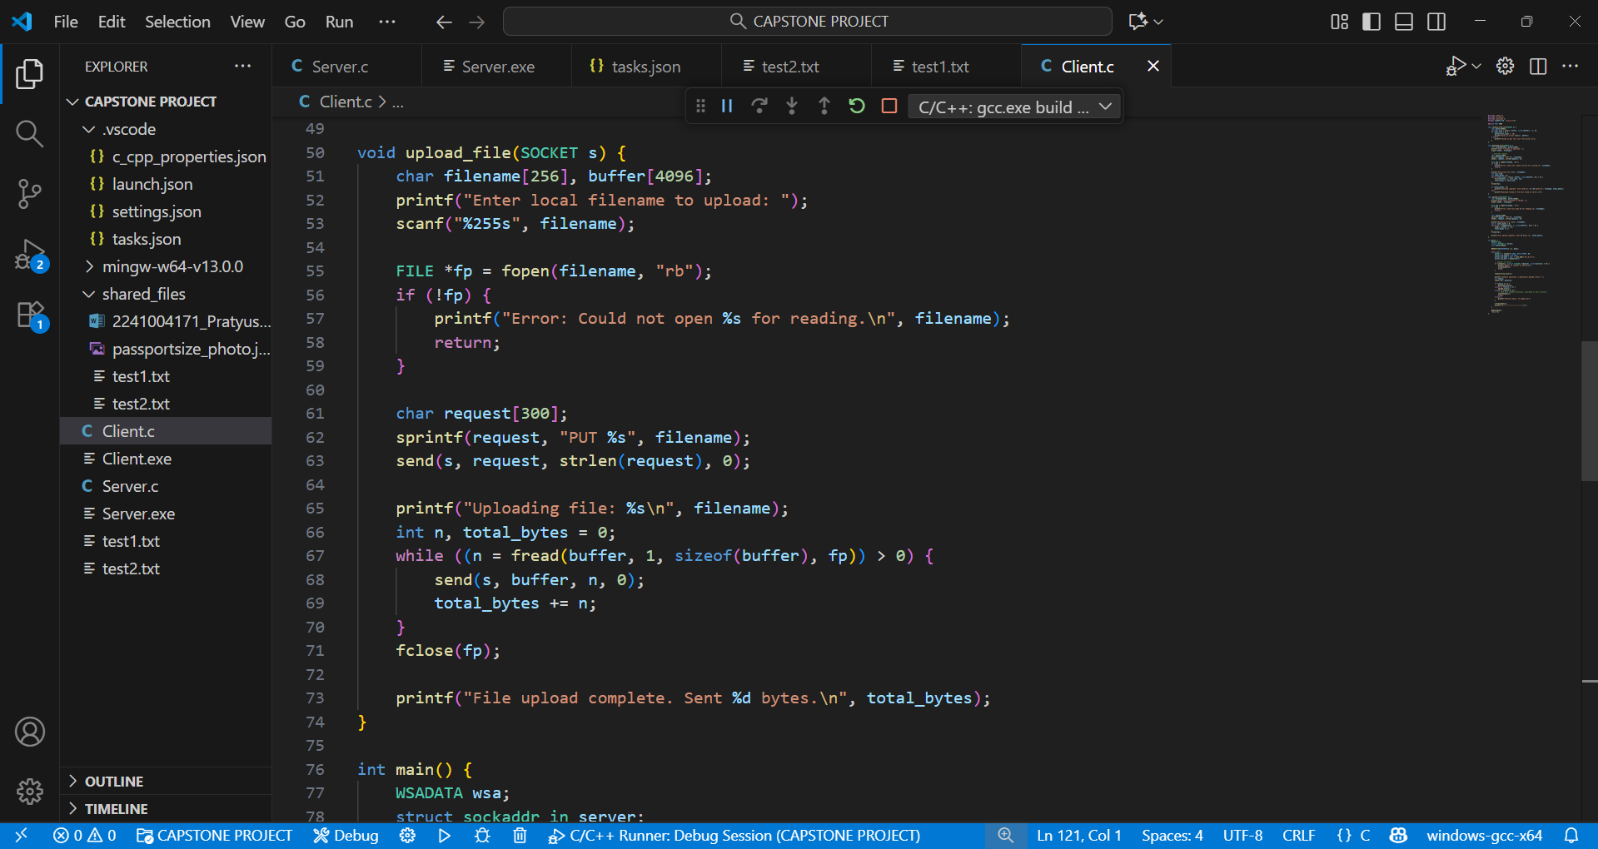

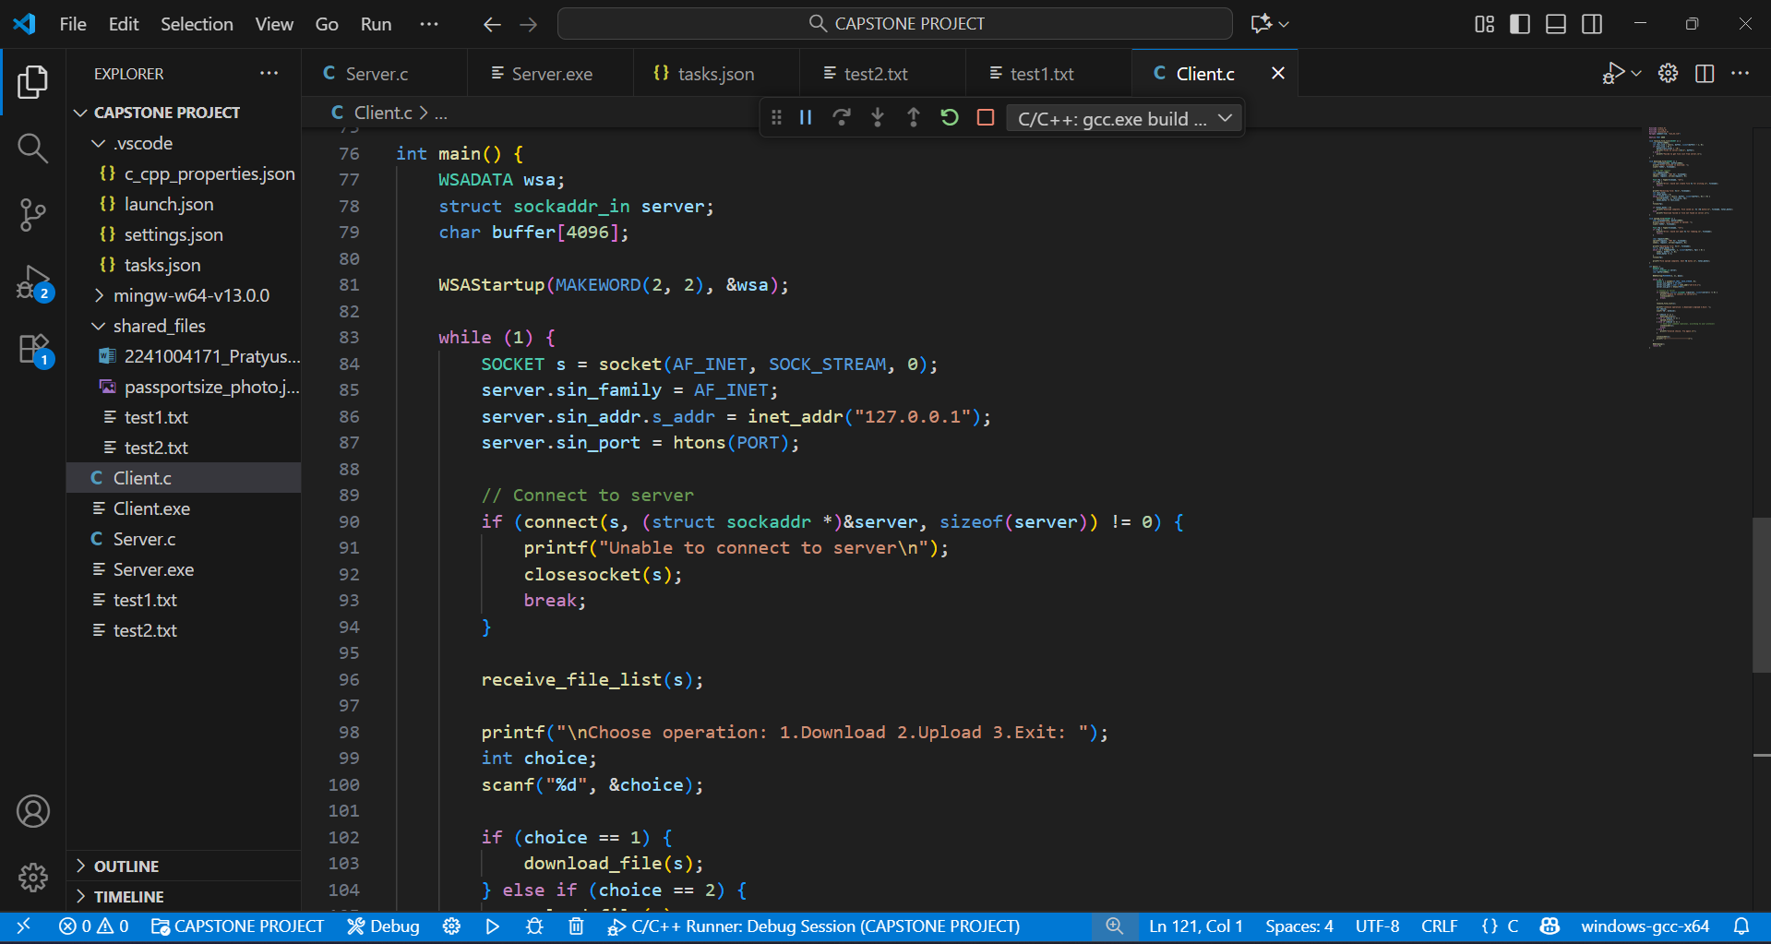

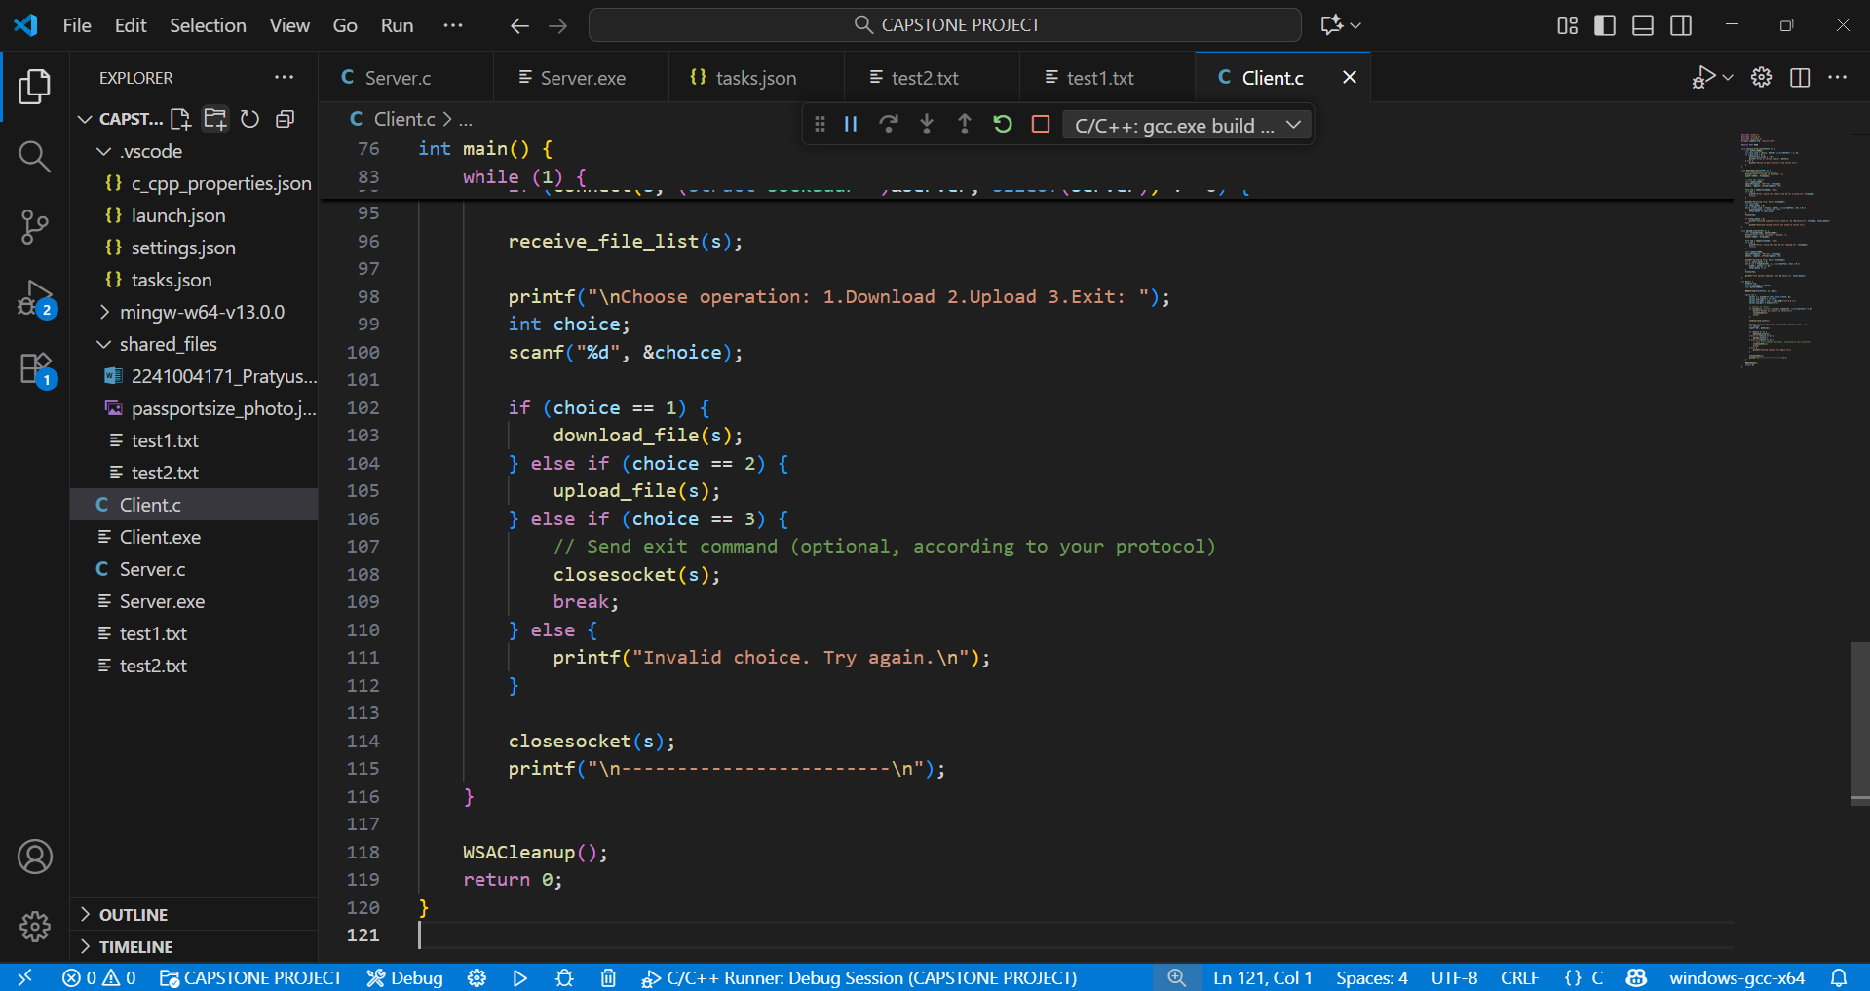

# Terminal Output:

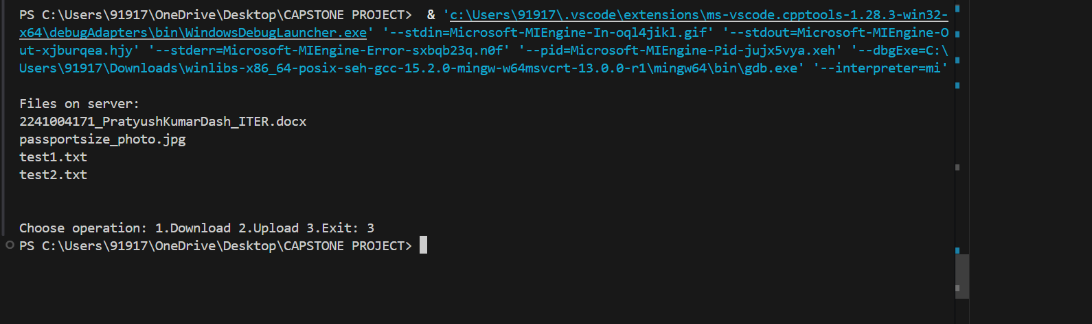

Name: Pratyush Kumar Dash  
Reg No: 2241004171  
Section: 12  
Batch: 3

Thank You …